Update Rate, CGI Design

Please fallow the steps in this document to upload rate file and manage rates

Rates are manage by admin teller for all.

* Once you update a rate for a currency individually or uploading CSV file using admin account, rates will be updated for all tellers

The first we should do is to add all the currencies teller need to operate buy and sell

To add currency to a teller account

1. Login with admin account and go to admin controls
2. Find the link Manage Existing Tellers and click on it
3. In the Teller Setting page click on “Add Currency For Teller”

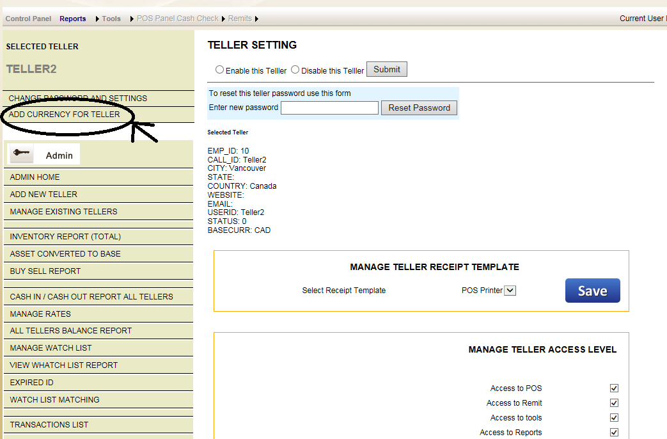

1. Please next image to learn how to add currency for teller
2. Repeat these steps for all tellers

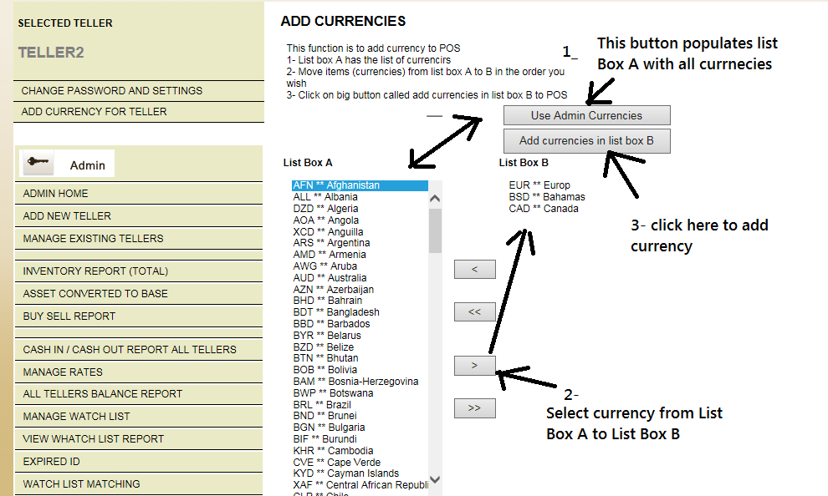

To update rates for all tellers using upload CSV file

The csv file has only 4 columns. Use the file provided by CGI Design team

1. Currency
2. Country
3. Buy rate
4. Sell rate

|  |  |  |  |
| --- | --- | --- | --- |
| **Currency** | **Country** | **Buy Rate** | **Sell Rate** |
| **AFN** | **Afghanistan Afghanis** | **0.02** | **0.02** |
| **CAD** | **Canadian dollars** | **1** | **1** |
| **USD** | **U.S. DOLLAR** | **0.9071941** | **0.90719405** |
| **GBP** | **United Kingdom Pounds** | **1.813882** | **1.887918** |
| **EUR** | **Euro** | **1.49205** | **1.55295** |

1. Log in with admin account and go to admin controls
2. Find the link called Manage Rates
3. Update the buy and sell rates on the CSV file and save it to local drive. Crate a directory for rate for example **c:\_rates**. Its good practice to save the file as (RATEYYYMMDD.CSV) Example rate20151120.csv for November 20, 2015 so you can keep track of the everyday rate changes in your rate files
4. In manage currencies page click on the Browse button
5. Select the file from your c:\_rates folder (it can be I any folder)
6. Click on Upload button

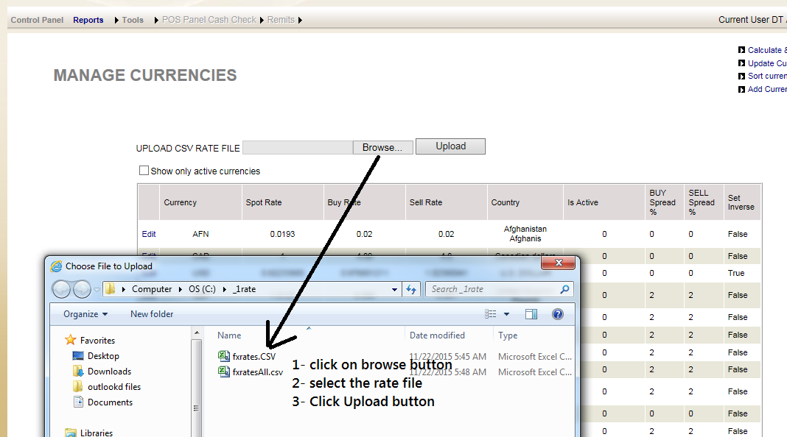

I you wish to update the rates directly in the form without uploading the CSV file, see the next image.

